TERRAFORM

Infrastructure as code

What is meant by infrastructure as a code?

Overview. Infrastructure as Code (IaC) is the managing and provisioning of infrastructure through code instead of through manual processes. With IaC, configuration files are created that contain your infrastructure specifications, which makes it easier to edit and

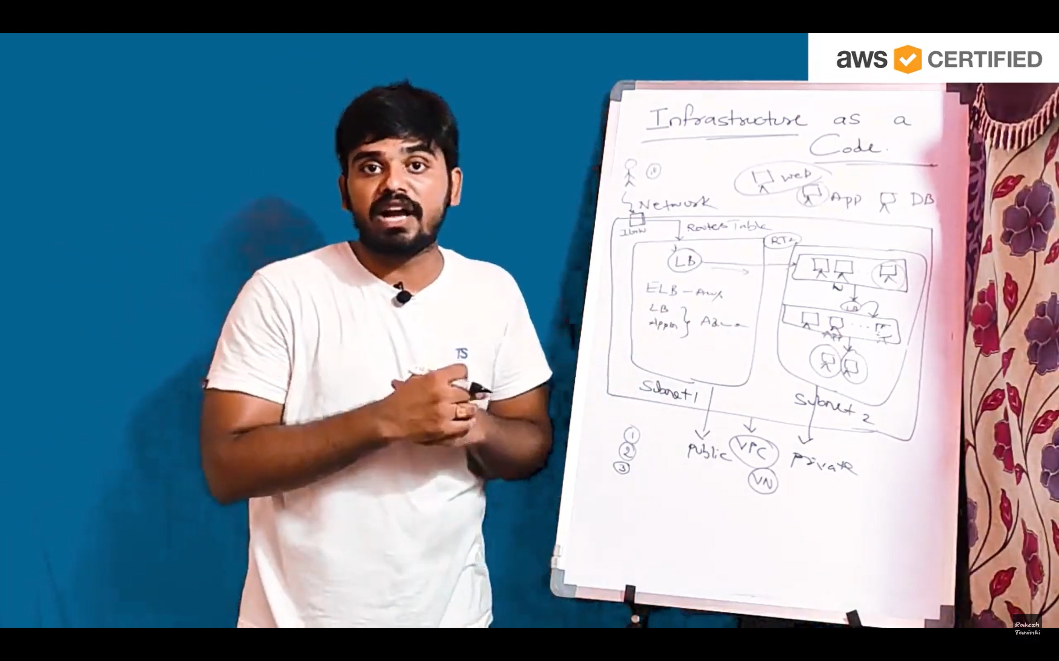

Which services is their in cloud platform to provide the infrastructure as code ?

AWS🡪 cloud formation template (CFT) : using this services to create the infrastructure as code in **aws** platform but its not going to support other cloud providers like **azur** platform

Azure🡪 azure resource manager template(ARM): using this service to create the infrastructure in azure platform but not others

** NOTE: here one tool is support both cloud platforms that is TERRAFORM. Its does perform both either aws or azure can create infrastructure and easy to convert to one cloud platform to another like aws to azure

Terraform is an infrastructure-as-code software tool created by HashiCorp. Users define and provide data center infrastructure using a declarative configuration language known as HashiCorp Configuration Language (HCL), or optionally JSON and YAML

** we are using some language to write the scripts in terraform or any cloud platform that languages we called declarative language.

1. JSON

2. YAML

What is a hybrid cloud?

A hybrid cloud—sometimes called a cloud hybrid—is a computing environment that combines an on-premises datacenter (also called a private cloud) with a public cloud, allowing data and applications to be shared between them

Hybrid cloud means combination of any two cloud provides we called

TERRAFORM

* [Terraform is an open-source Infrastructure as Code (IaC) tool developed by Hashicorp1](https://www.and.digital/spotlight/what-is-terraform-why-use-it).
* [It is used to manage infrastructure as code and has grown increasingly popular in recent years as cloud infrastructures have become more widely adopted1](https://www.and.digital/spotlight/what-is-terraform-why-use-it).
* [Terraform enables you to develop infrastructure code, makes it simple to rebuild and track changes to the infrastructure, and gives extensive infrastructure information2](https://unixcop.com/why-should-you-use-terraform-and-how-does-it-work/).
* [Terraform offers a great way to package and reuse common code in the form of modules3](https://www.fairwinds.com/blog/what-is-terraform-and-why-is-it-important).
* [It presents a standard interface for creating resources by providing inputs and returning outputs3](https://www.fairwinds.com/blog/what-is-terraform-and-why-is-it-important).
* [Terraform is platform-agnostic, meaning that the product is not limited to one platform or operating system4](https://www.simplilearn.com/what-is-terraform-and-what-is-it-used-for-article).
* [It provisions resources across multiple cloud providers such as AWS, Azure, GCP, and more5](https://developer.hashicorp.com/terraform/intro).
* [There are four particularly important reasons why you might choose Terraform over other tools: Declarative vs Imperative, Immutable vs Mutable, Configuration Management vs Orchestration, and Size of The Community](https://www.and.digital/spotlight/what-is-terraform-why-use-it)

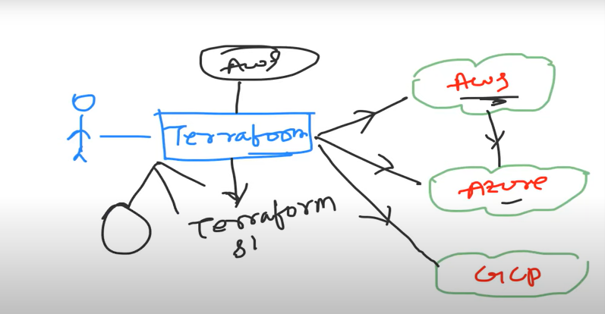

Terraform lifecycle

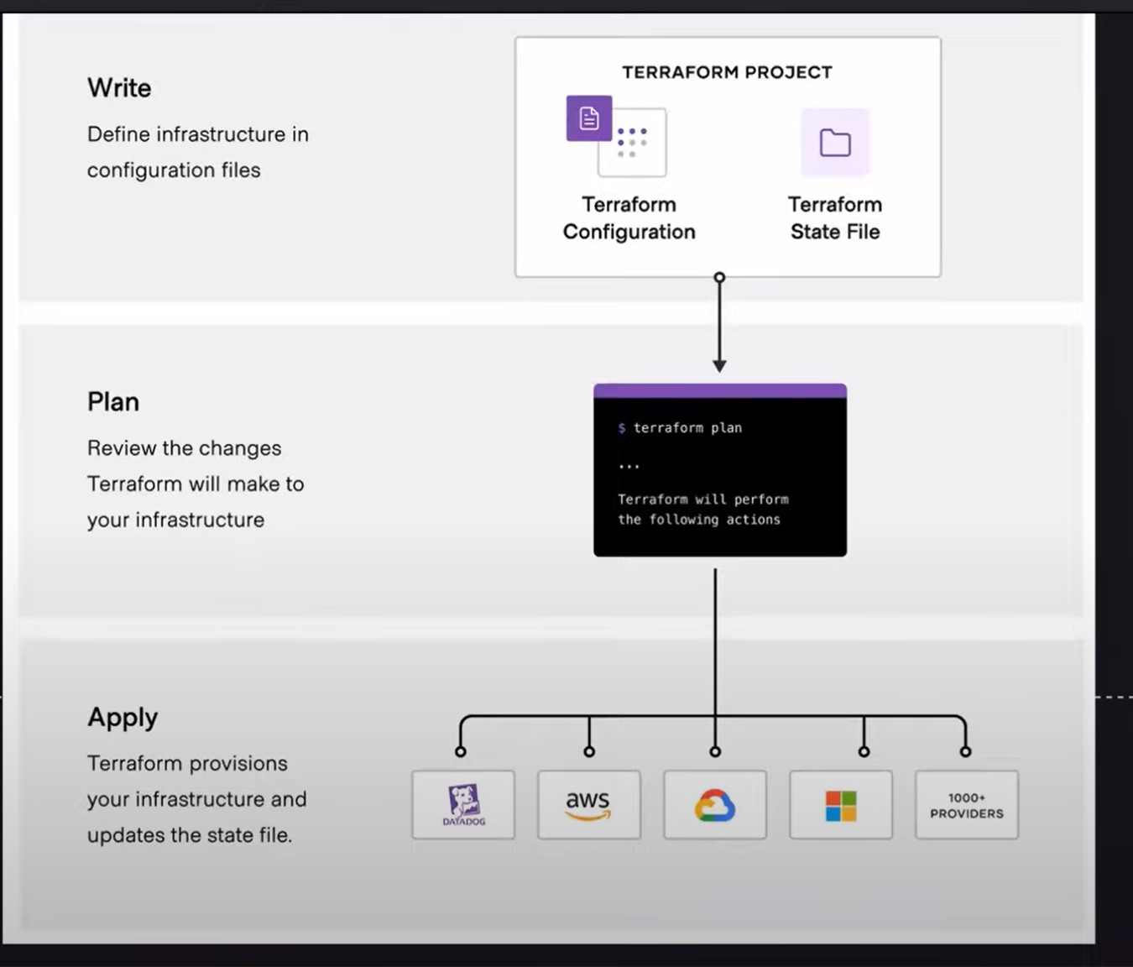

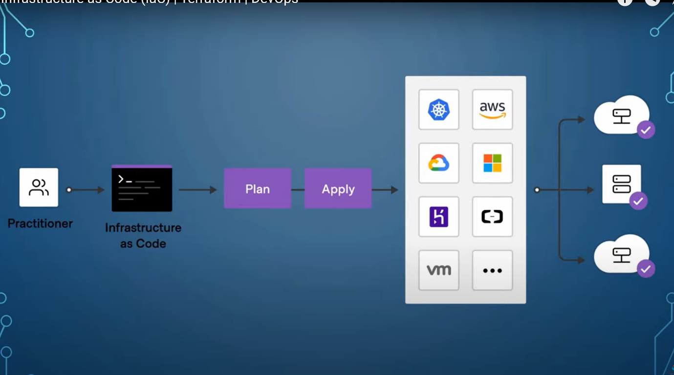

Infrastructure as code:

1. TERRAFORM TOOL

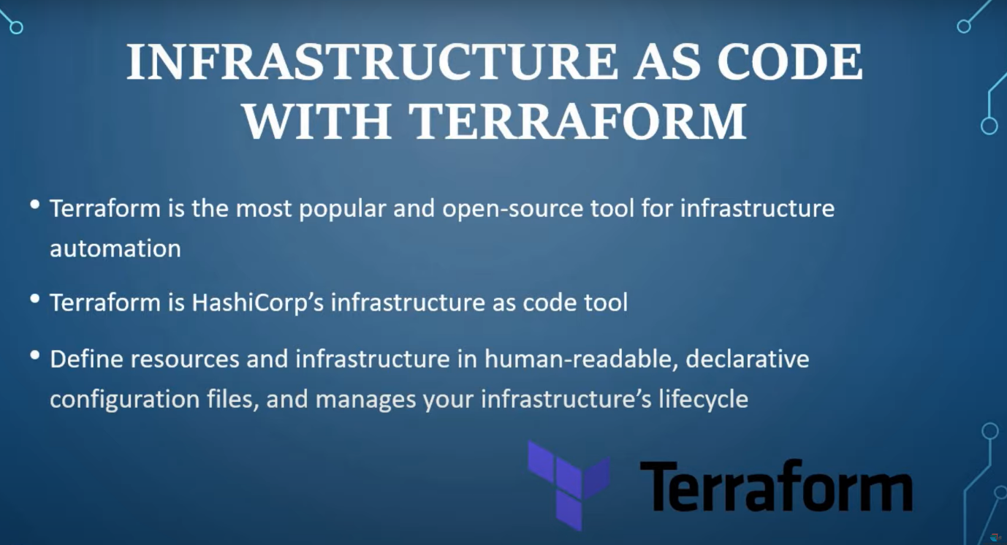

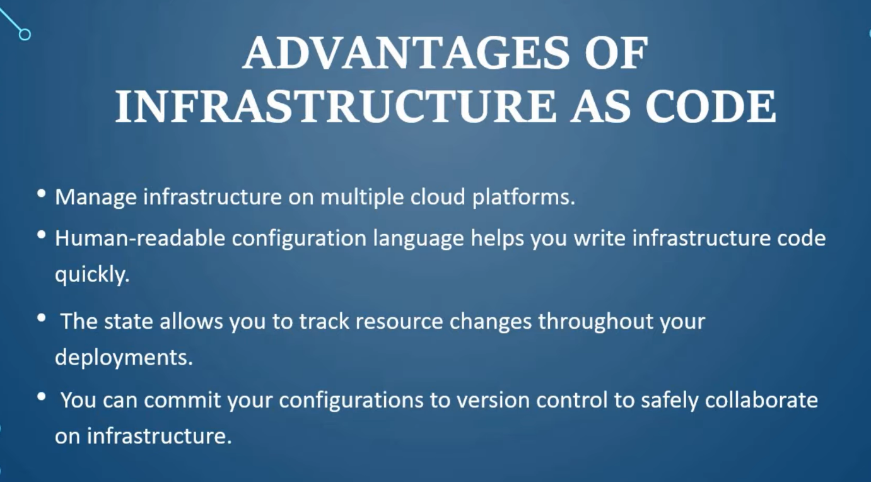

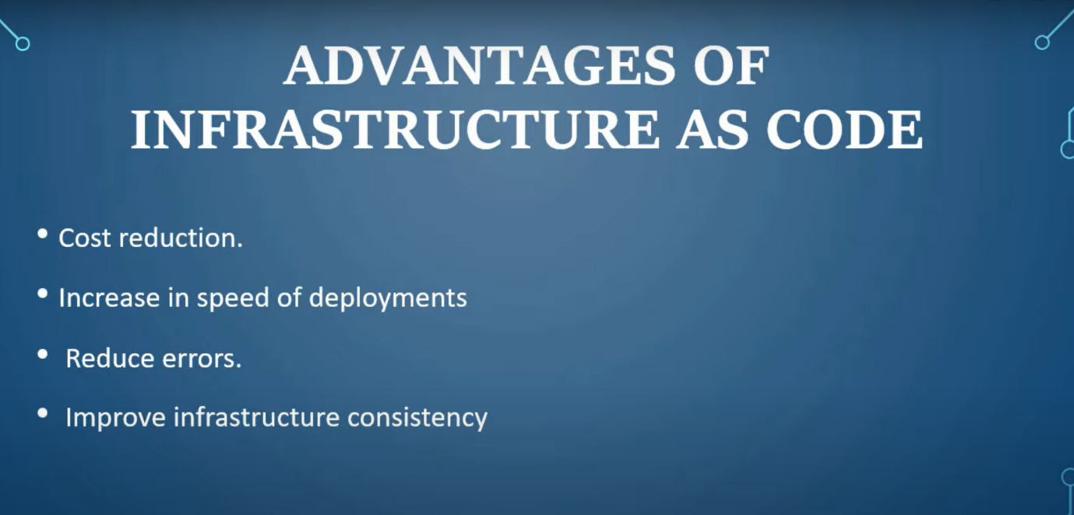

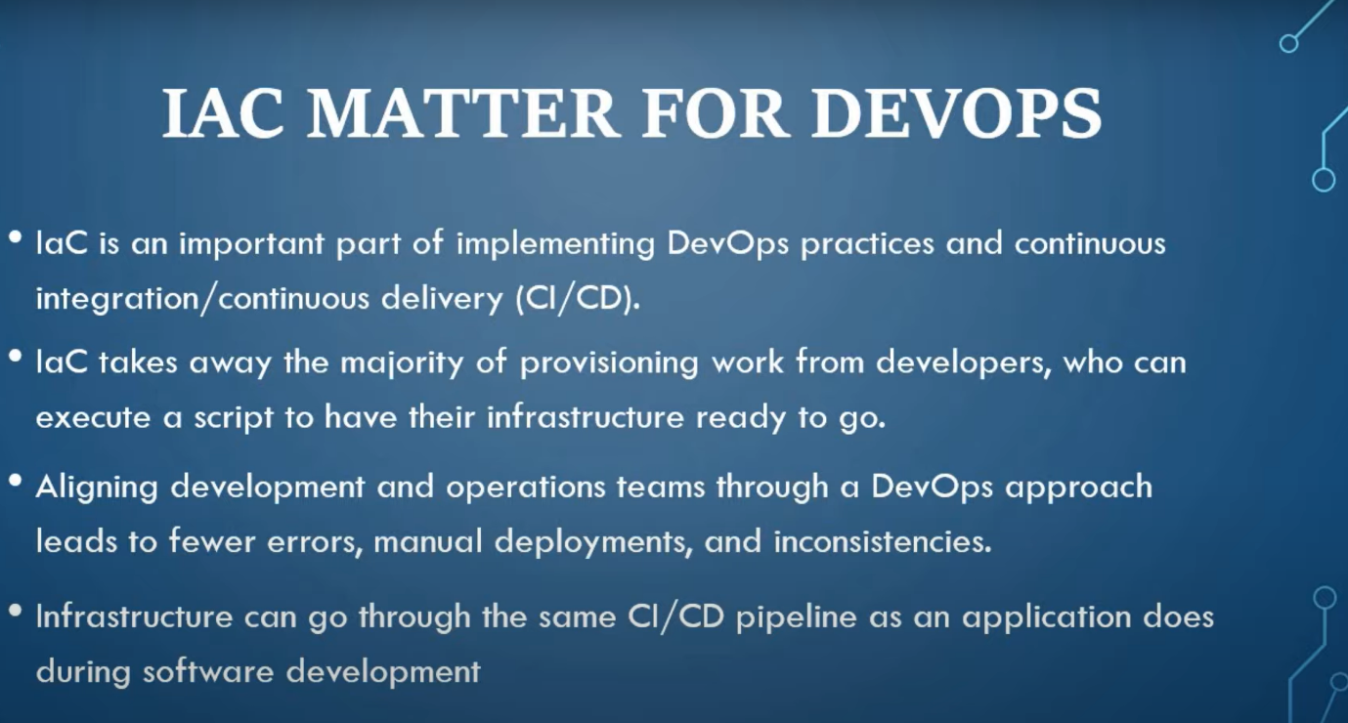

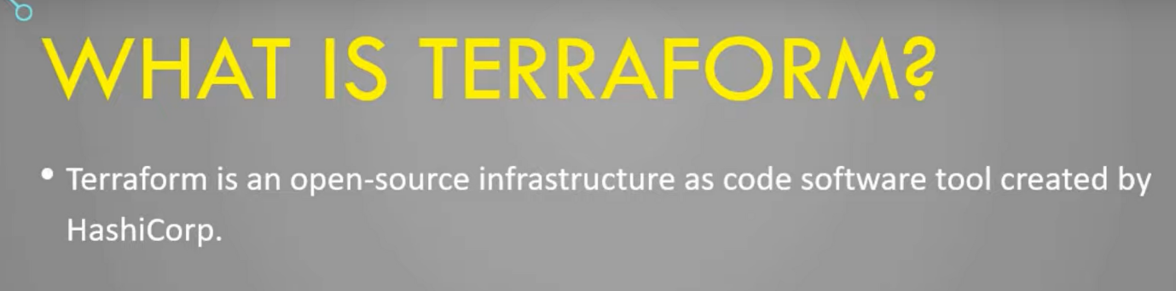

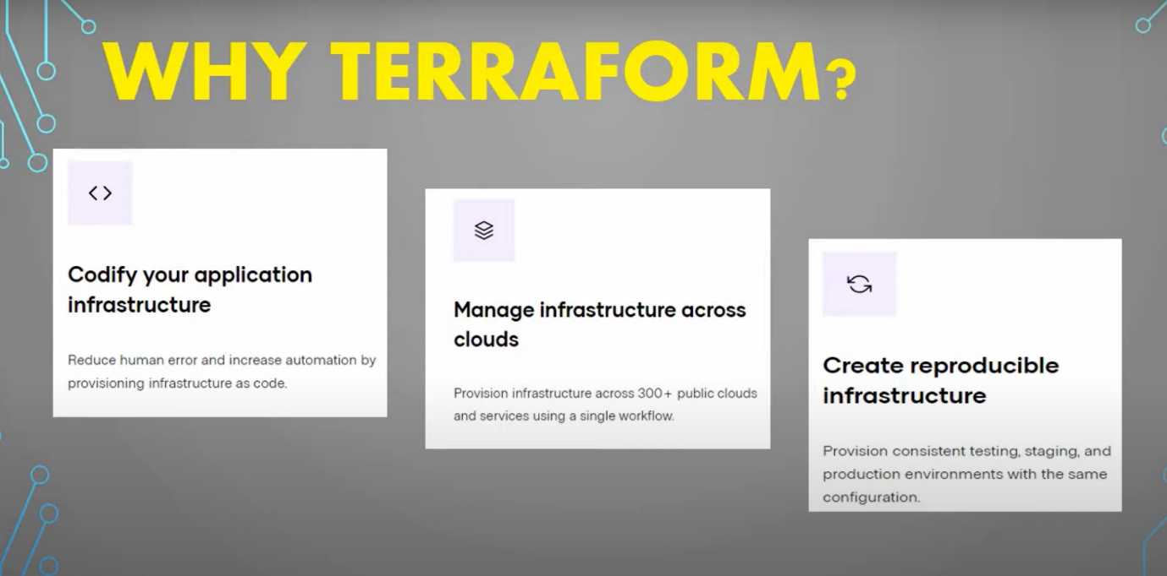

Why terraform :

1 speed

2 consistency

3 scalability

Different IAC tools:

Ansible

Chef

Puppet

Naku oka doubt terraform okatena ledha ansible,chef,puppet kuda multiple cloud provides haa ani doubt

* Open-source & proprietary:

Cloud formation

ARM

This tools also open source but we are using terraform why because cloud formation and ARM this two not going to support to another cloud providers that why all are using TERRAFORM.

* Terraform is using simple language HCL (hashi corp language)

This language is easy to understand

Terraform tool is developed by “ go “ and “HCL” Language

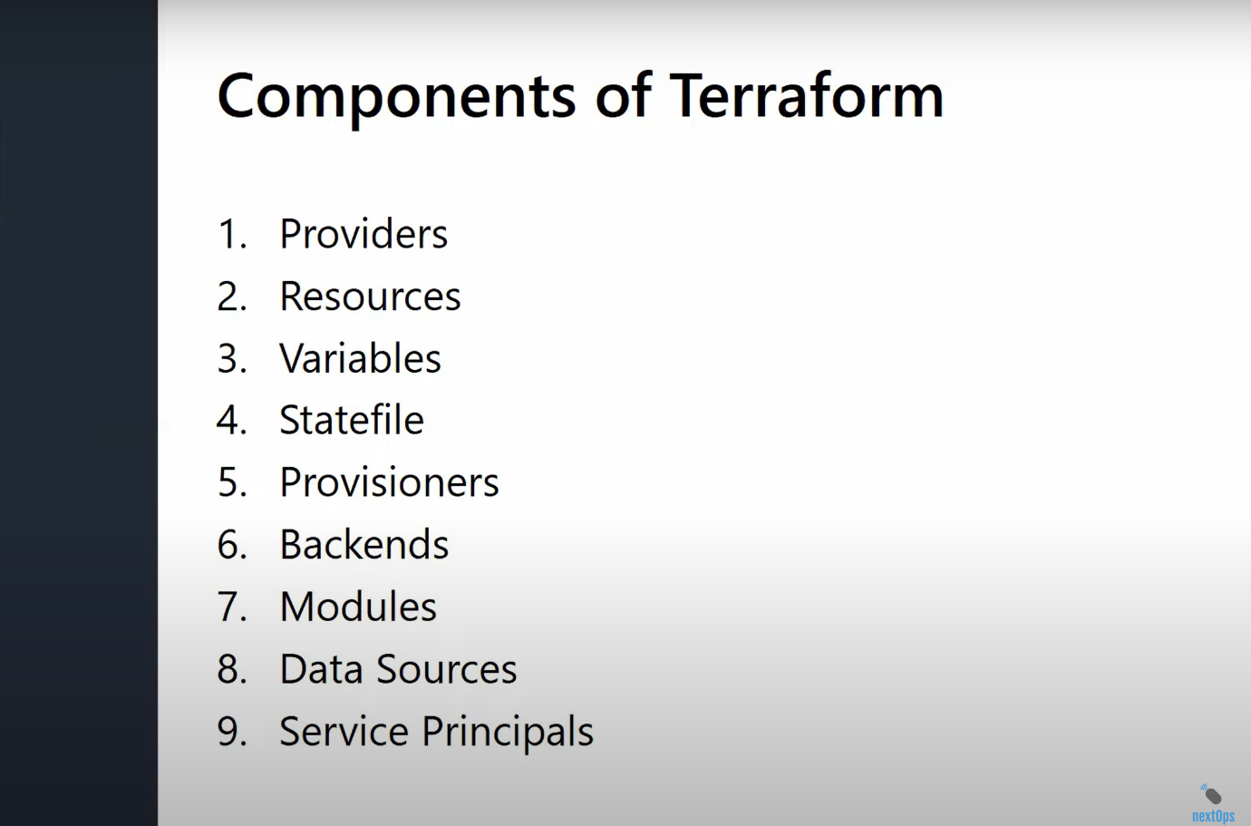

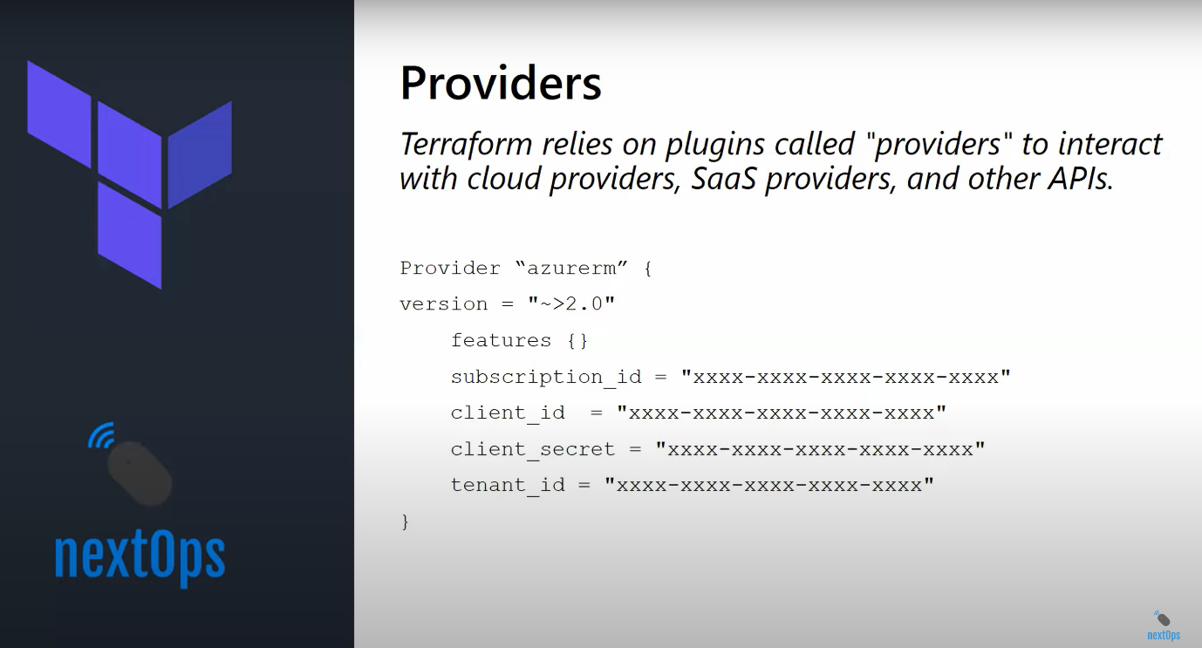

Every resource type is implemented by a provider; without providers, Terraform can't manage any kind of infrastructure.

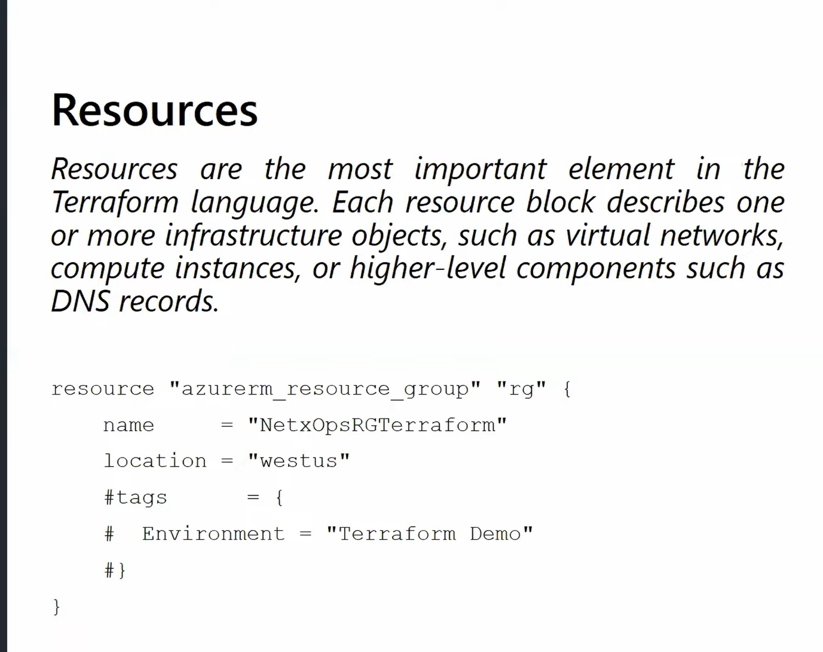

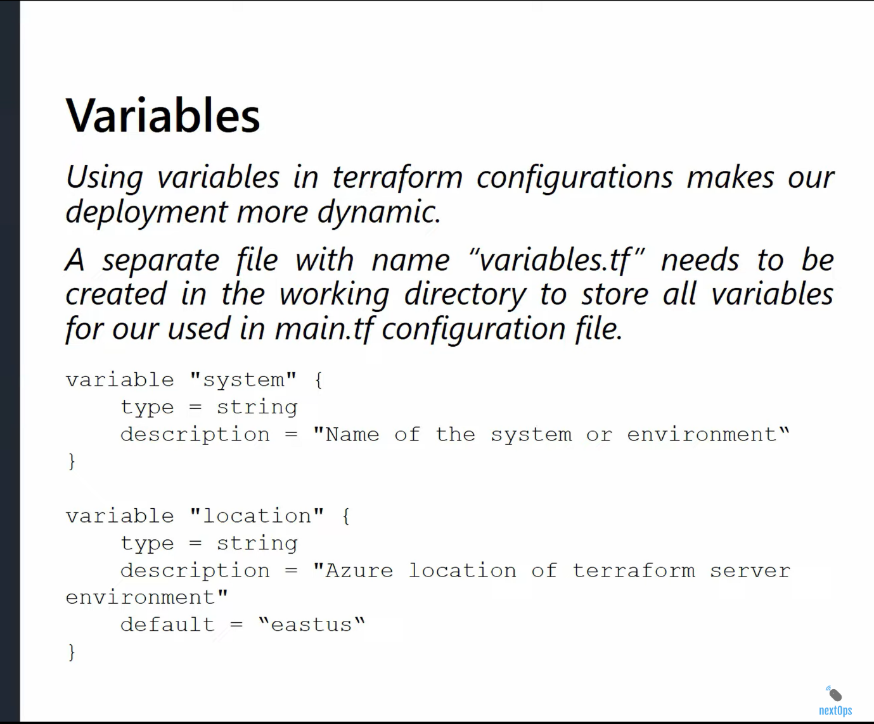

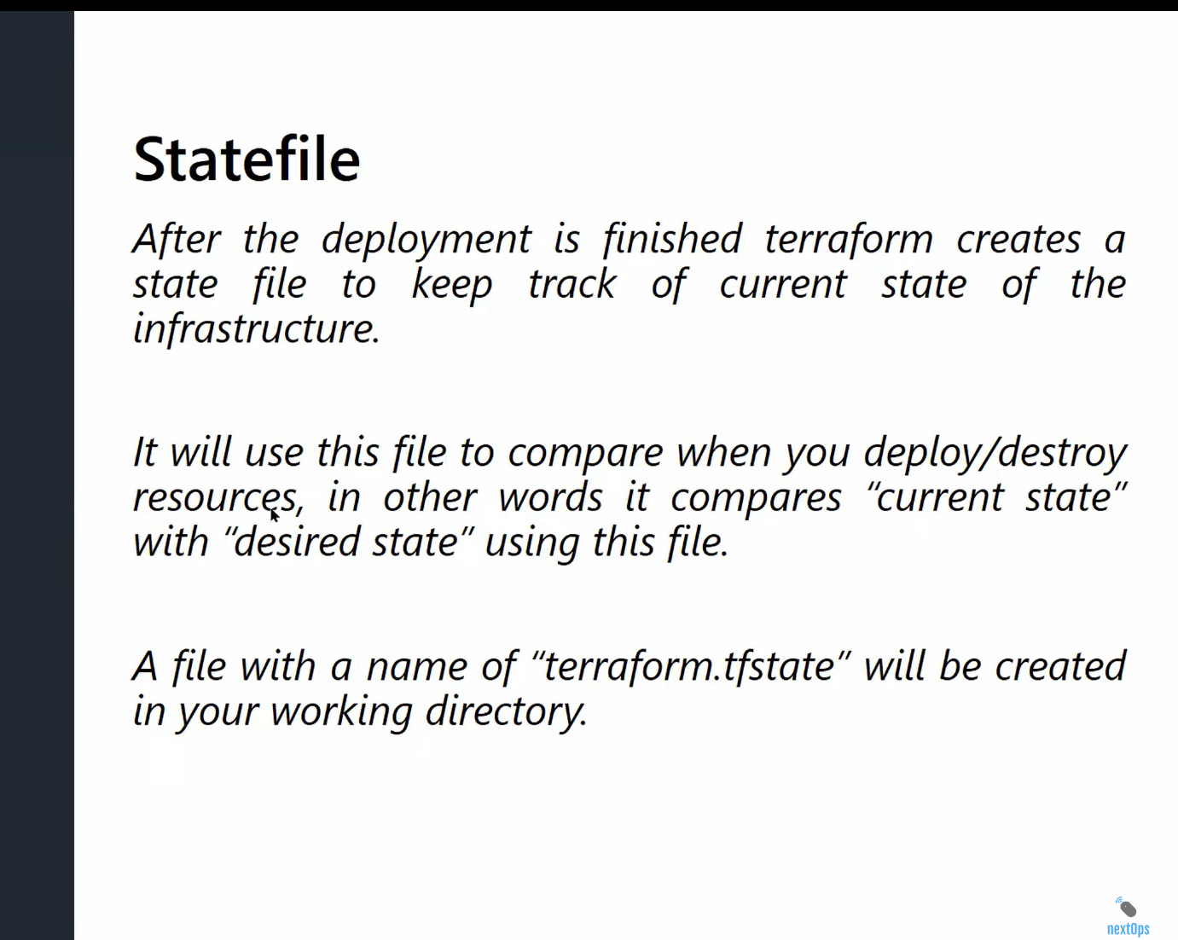

State file:

* Terraform is using stat file this is track every thing it created.
* You should share your state file remotely back end ( means remote storage services like S3 bucket). Not on your local machine!
* *** Once integrating with locking mechanism(dynamo db ) Terraform will not allow parallel execution of terraform scripts, this is the ideal process all organization
* It is not a good idea to store the state file in source control
* Isolate and organize the state files to reduce the blast radius

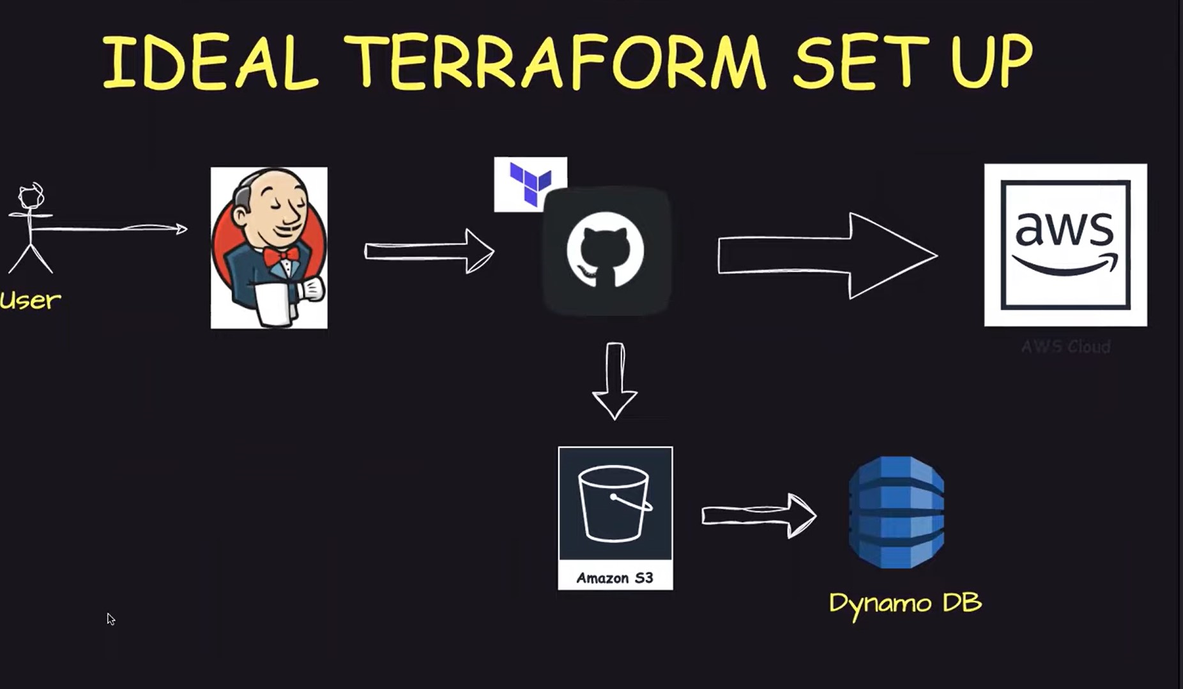

<https://youtu.be/zoBeyv3Asl0?si=rDTyB1JwNBma9f-6>

* How to write terraform script will know after seeing this video

<https://youtu.be/tNeRFiN4eT8?si=cv1k8BLUeYwMx2d_>

How to write Terraform script

* First we need to install “CLI“ in terminal
* Then configure the AWS CLI to terminal
* For that we need “accesskey” this access key find in IAM create one new access key after that provide that keys in “aws configure”
* Type command to configure : “aws configure” and provide there and select region and format (json)
* This how configure the aws cli in your terminal. Now started to interact you aws account when your writing terraform script

Terraform commands:

1 terraform init

2 terraform validate

3 terraform plan

4 terraform apply

5 terraform destroy

I wrote one simple script for creating one instance :

terraform {

required_providers {

aws = {

source = "hashicorp/aws"

version = "~> 5.0"

}

}

required_version =">= 1.2.0"

}

resource "aws_instance" "my_instance" {

ami = "ami-0fc5d935ebf8bc3bc"

instance_type = "t2.micro"

tags = {

Name = "HelloWorld"

}

}